 Teacher: Janice Fernandez
About: Full time ICAN Teacher, sometimes stage actress. For her, nothing is worse than being ordinary. Her famous line?” I have trouble acting normal.”

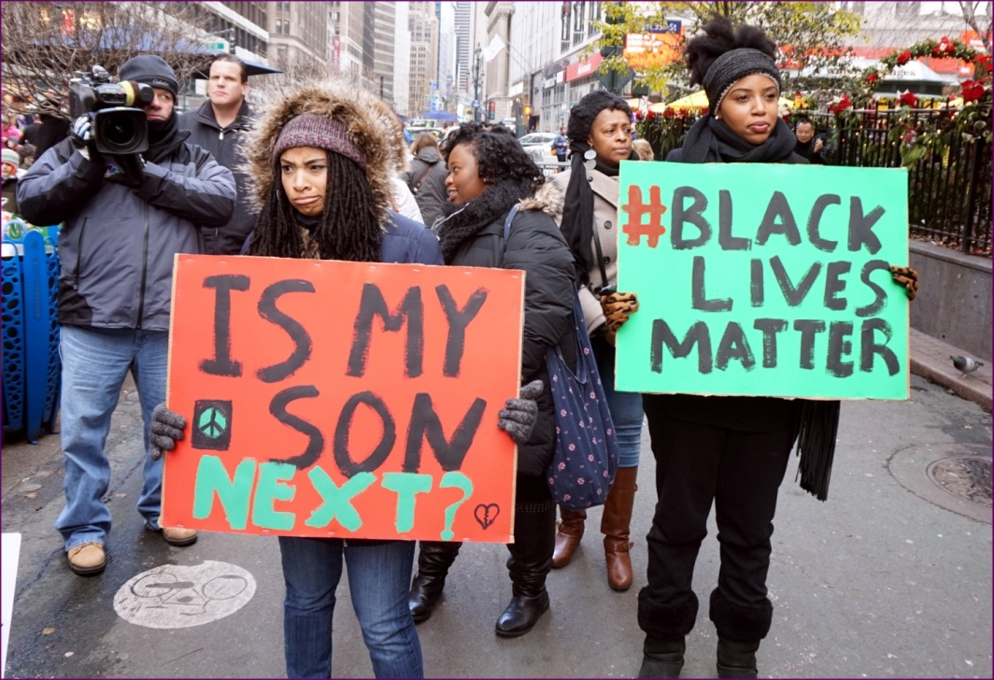

Black Lives Matter
Black Lives Matter is an activist movement in the United States that began in the wake of the July 2013 acquittal of George Zimmerman in the Florida shooting death of African-American teen Trayvon Martin. The Black Lives Matter movement campaigns against what it calls police brutality in the United States against African-Americans. The group received fresh impetus from the 2014 deaths of two unarmed African Americans, teenager Michael Brown in Ferguson, Missouri and 43-year-old Eric Garner in New York City; in both cases the grand jury did not indict the officers and no charges were brought. Several unarmed African Americans who died at the hands of law enforcement have had their deaths protested by the movement, including Tamir Rice, Eric Harris, Walter Scott, and Freddie Gray (whose death sparked the 2015 Baltimore protests). Several media organizations have referred to it as "a new civil rights movement."^{[1][2][3]} However, several conservative pundits have labeled the movement a "hate group."^{[4]}
The movement was co-founded by four black activists: Alicia Garza, Patrisse Cullors, Opal Tometi and Crystal Rose.^{[5][6][7]}Although the Alicia Garza, Patrisse Cullors and Opal Tometi run a stable website and organization, the overall Black Lives Matter movement is a decentralized network, and has no formal hierarchy or structure.^{[8]} The movement reached national awareness with the protests and unrest in Ferguson in August 2014, although Garza, Cullors and Tometi were not initially involved in those events.^{[2][9]}

Vocabulary Highlights:

1.) activist (noun) /ˈæk.tɪ.vɪst/ - a ​person who ​believes ​strongly in ​political or ​social ​change and ​takes ​part in ​activities such as ​public ​protests to ​try to make this ​happen.
Ex. He's been a ​trade ​union/​party activist for many ​years.an ​animal ​rights activist

2.) acquittal (noun) /-ˈkwɪt̬-/ - the ​decision of a ​court that someone is not ​guilty.
Ex. The first ​trial ​ended in a ​hung ​jury, the second in acquittal.
Of the three ​cases that went to ​trial, two ​ended in acquittals.

3.) impetus (noun) /ˈɪm.pɪ.təs/ - something that ​encourages a ​particular ​activity or makes that ​activity more ​energetic or ​effective.
Ex. The ​recent ​publicity ​surrounding ​homelessness has given (a) ​fresh impetus to the ​cause.

4.) indict (verb) /ɪnˈdaɪt/ - If a ​law ​court or a grand jury indicts someone, it ​accuses them ​officially of a ​crime.
Ex. He was indicted on ​drug ​charges at Snaresbrook Crown ​Court.
US Five ​people were indicted for making and ​selling ​counterfeit​currency

5.) pundit (noun) /ˈpʌn.dɪt/ - a ​person who ​knows a lot about a ​particular ​subject and is ​therefore often ​asked to give an ​opinion about it.
Ex. a ​political/foreign-policy/​sports pundit

6.) decentralized (adjective) /ˌdiːˈsentrəlaɪzd/ - used to describe ​organizations or their ​activities which are not ​controlled from one ​central ​place, but ​happen in many different ​places.
Ex. The ​management ​structure is ​highly decentralized.
Decentralized decision-making.

Grammar Focus

The Simple Present
The simple present tense is used when:
- we talk about something that happens normally
- we talk about scheduled actions or activities
- something is generally true
- something is permanent

Ex.
The Black Lives Matter movement campaigns against what it calls police brutality in the United States against African-Americans.
Black Lives Matter is an activist movement in the United States.
How do we make Simple Present sentences?
1 [ Singular subject + verb(s/es) + time expression/ object ]
2 [ Plural subject + verb (base form) + time expression/object ]
Ex. Alicia Garza runs a stable website and organization.
Alicia Garza, Patrisse Cullors and Opal Tometi run a stable website and organization.
We also make it using adjectives, especially when we are talking about a person or thing. This is when something is generally true about a person or an object.
1 [ Singular subject + am/ is + adjective ]
2 [ Plural subject + are + adjective ]
Ex. The Black Lives Matter movement is decentralized.
The pundits are wrong.

How do we make Simple Present Questions?

1 [ Does + singular subject + verb (base form) + ? ]

2 [ Do + plural subject + verb (base form) + ? ]

There are times when we want to ask more specific information about something. When we do, we use the different WH-questions.

Who – is used to ask questions regarding people
When - is used to ask questions regarding time of action
Where - is used to ask questions regarding places and locations
What – is used to ask questions regarding objects and situations
Why – is used to ask questions regarding the reason for an action
How – is used to know the way an action is done or completed

When detail questions are asked, the formation of the question changes. There are items that are included and some that are excluded.
[ Who + am/ is/ are + subject + ? ]

Ex. Who is she?
Who are they?
Who is George Zimmerman?

[ Who + verb (s/es) + object + ? ]

Ex. Who runs the website?
Who campaigns against the police brutality?

[ When + do/ does + subject + verb (base form) + object + ? ]

Ex. When do they start campaigning?
When does he get indicted?

[ Where + do/ does + subject + verb (base form) + ? ]

Ex. Where do they protest?
Where does Alicia study?

[ What + do/ does + subject + do + ? ]

Ex. What does the movement do?
What do they do for a living?

[ Why + do/ does + subject + verb (base form) + object + ? ]

Ex. Why does he like to be armed?
Why do they run the organization?

[ Why + do/ does + subject + do + that + ? ]

Ex. Why do they do that?
Why does he do that?

How do we make Simple Present Negative sentences?

1 [ Subject + do/ does + NOT + verb (base form) + object ]

2 [ Subject + am/ is/ are + NOT + adjective ]

Ex. Andrea does not join the group.
Stella does not like to protest.
Gwen and Stacy do not agree with them.
His family is not happy about it.
The police are not playing their role.

Reading Comprehension Questions
1. What does the movement The Black Lives Matter campaign against?
2. When did it begin?
3. Who co-founded the movement?
Critical Thinking Questions
1. Why have several conservative pundits labeled the movement a “hate group”?
2. How do you feel about police brutality and racism?
3. How can we stop police brutality in the black community?

Teacher’s Blog (opinion):
In my opinion, the Black Lives Matter movement is just one way for black people to exercise their democratic freedom. They do not have the right to create chaos in some areas of the United States, but they do have the right to express their sympathy towards the extra judicial killings of black people by police and vigilantes in recent years. The movement seeks justice for these people.

The movement likewise wants the U.S. government leaders to find ways to end the racial profiling, police brutality, militarization of many U.S. police departments, and the mass incarceration of African- Americans.


(Audio)

Students Comment:


(Video)

